PAST 1

CÂU 1

def KT(arr):

count =0

for i in arr:

if(i<2):

count=count+1

else:

for j in range (2,i-1):

if(i%j==0 and j<i):

count= count+1

break

return len(arr)-count

a= [1,3,5,6,7,11,13,17,16]

print(KT(a))

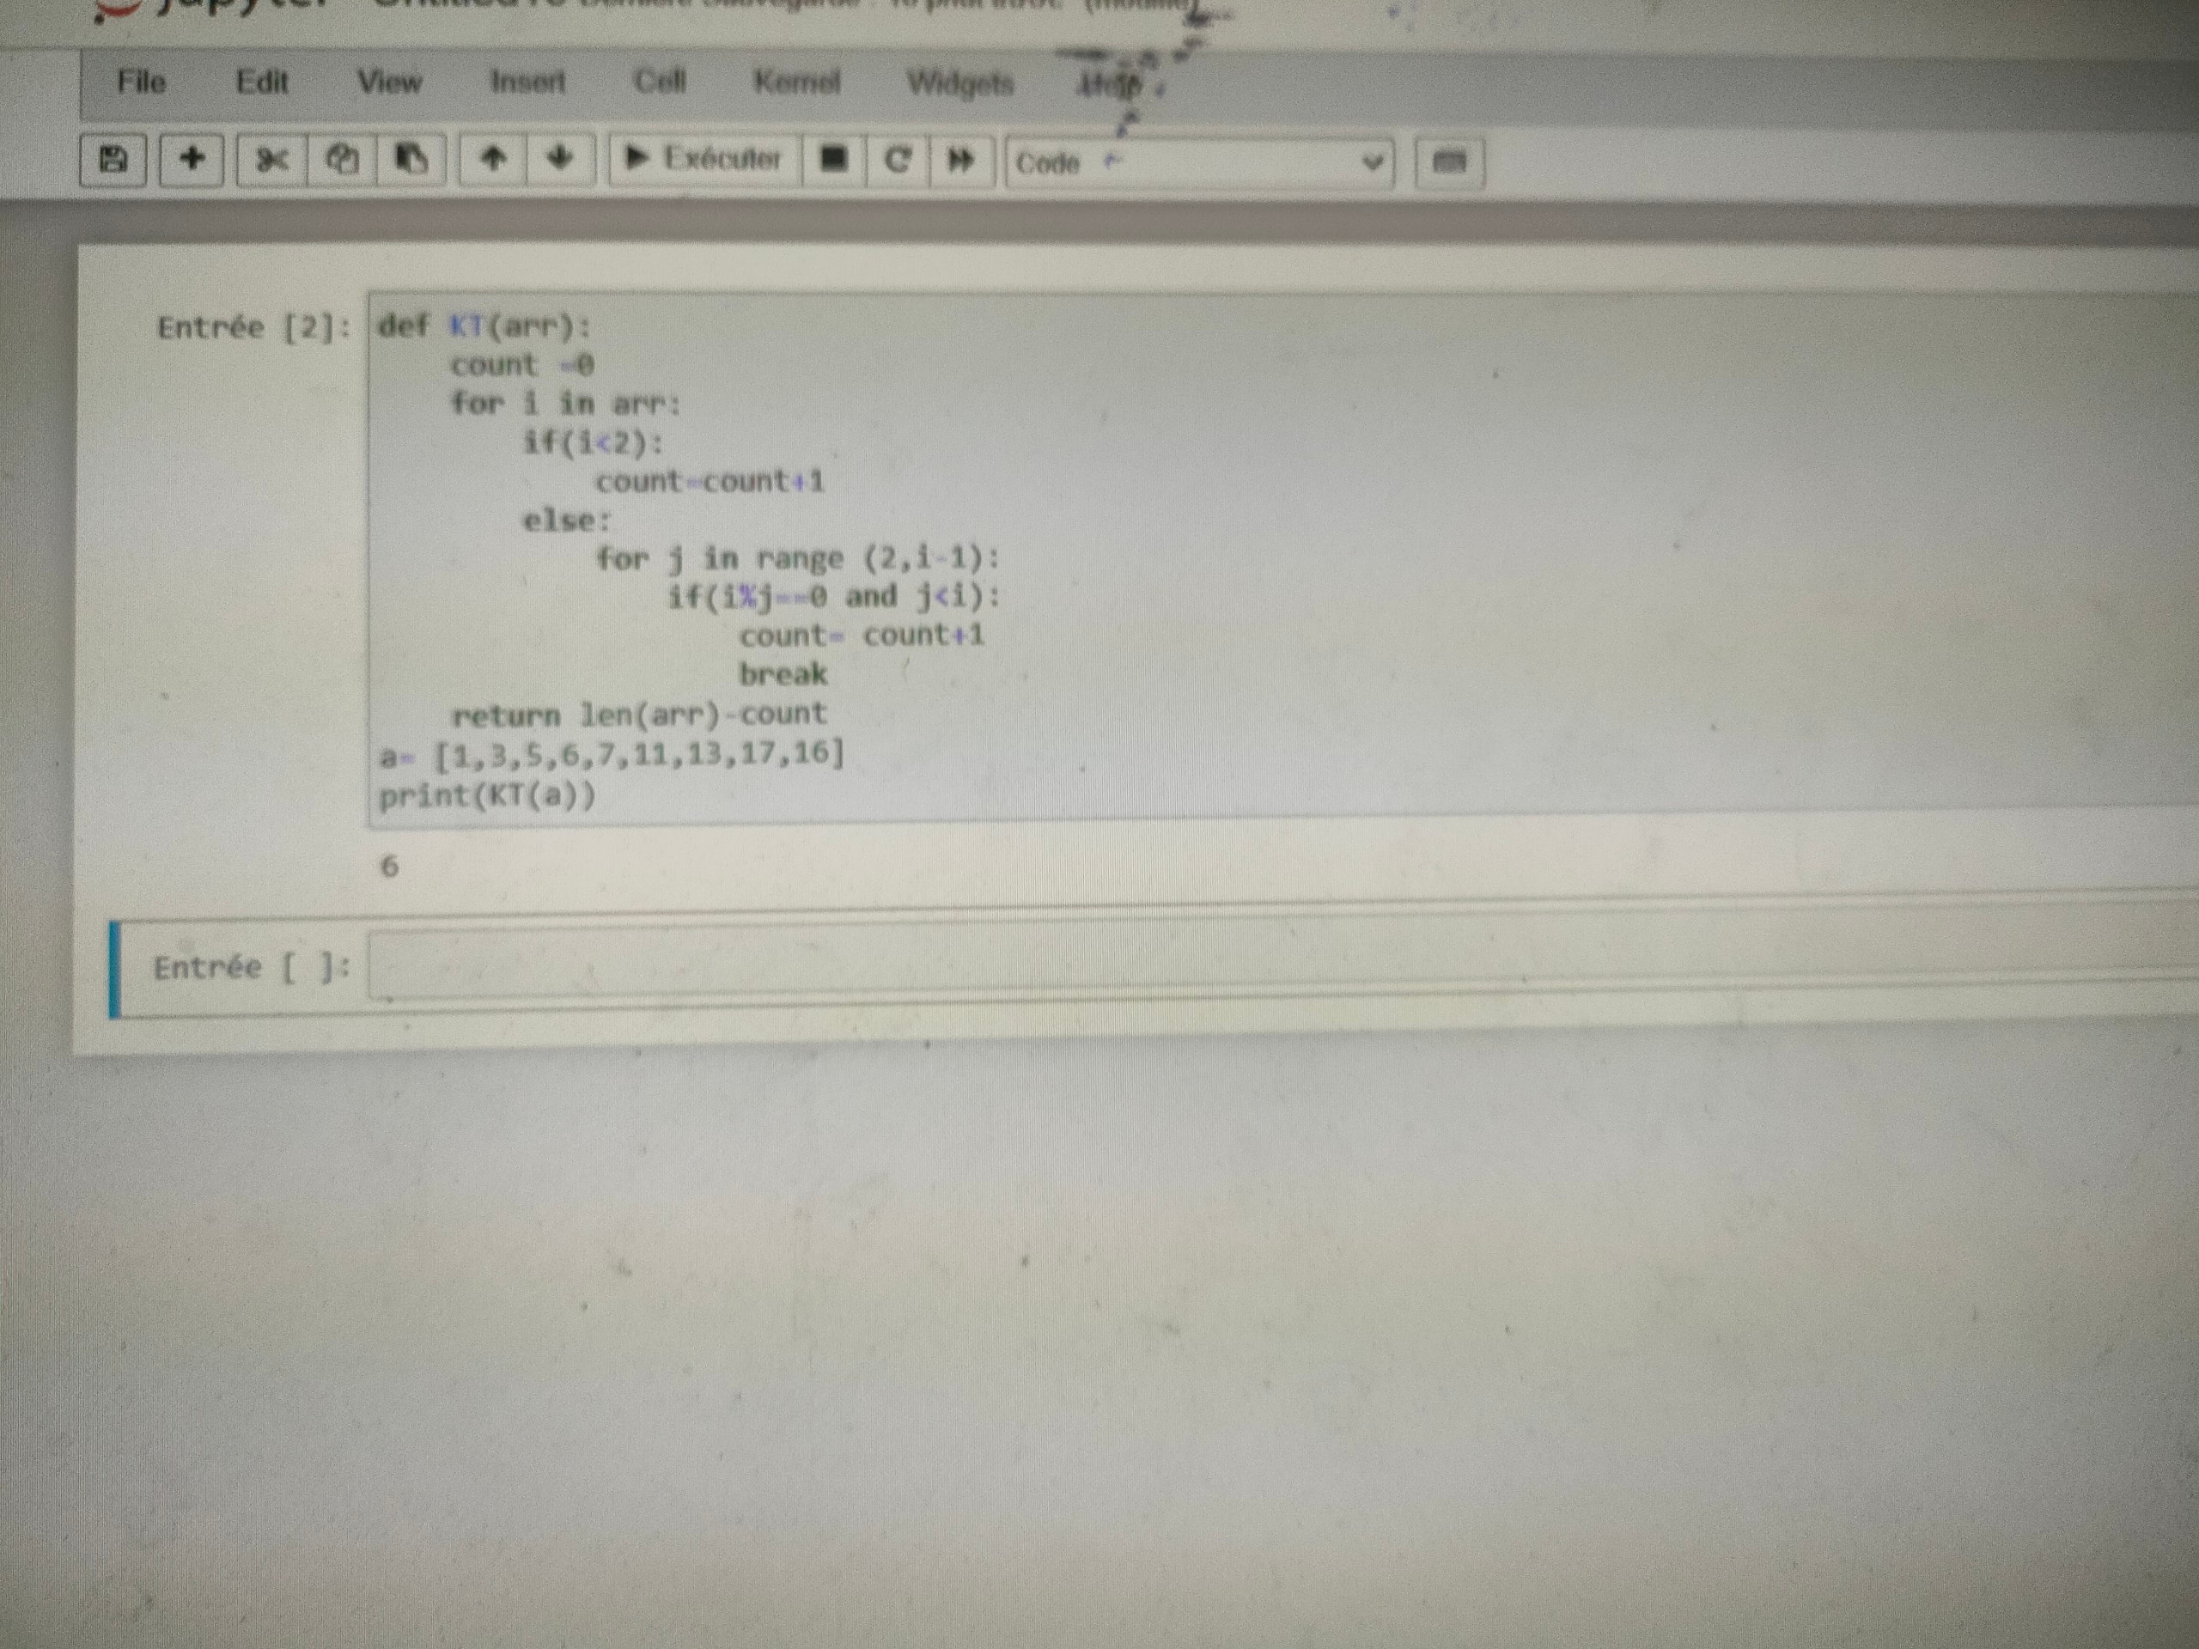

PAST 2

CÂU 2

- select c.city, sum(c.grade) sum_of_grade from customer c group by c.city

- select * from customer c join salesman s on c.salesman_id = s.salesman_id where s.commission > 0.12 order by c. customer_id